Cumulated CO₂ emissions as metrics for speeding up buildings’ retrofitting
Gebäudesektor
Iná MAIA⁽¹⁾, Lukas KRANZL⁽¹⁾, Andreas MÜLLER⁽²⁾,Daniel HARRINGER⁽¹⁾
⁽¹⁾EEG – TU Wien, ⁽²⁾e-think

Motivation
Due to the seriousness of the current energy prices and energy security situation and the urgent need of building stock decarbonisation, we aim at analysing different aspects of accelerating the building stock decarbonisation: on one hand the effect of energy prices on the viability of different renovation measures, and on the other hand the difference of single stage versus staged building renovation. In this context, we also suggest the use of an indicator to take into consideration the time perspective, i.e. the timing of renovation measures and the resulting demand over time. Therefore, in the current case study we introduce the cumulated primary energy demand over the whole period until 2050 (based on EU’s decarbonisation target [1]) as an indicator for assessing the energy demand of a building over a certain period of time. This work is part of the case study researched during the EU H2020 Project ENEFIRST.
Method
We start with a definition of reference buildings and possible, suitable renovation measures with different energy efficiency standards (step 1). Subsequently, we define different packages of renovation measures and then allocate them in staged renovation steps (step 2). Investment costs and energy demand (step 3) are calculated for each building roadmap, using the cost-optimality method (as defined in the EPBD – Energy Performance of Buildings Directive[2]). Following a net-present value maximization algorithm[3], in step 4 we determine the optimal timing of renovation steps, before finally identifying the cumulated primary energy demand and global costs of staged renovation processes (step 5).
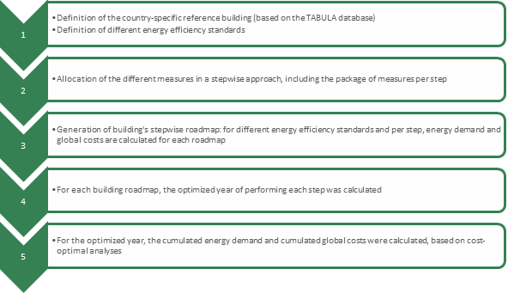
Results
In general, between the different combinations of measures the primary energy demand difference is 11 kWh/m² (between 49 to 38 kWh/m²) and specific global costs difference of 51 €/m² between (605 and 554 €/m²). The external wall insulation has higher impacts on the primary energy demand. The change in the energy price affects the specific global costs but not the primary energy demand (when maintaining the same heating system replacement option). The graph also shows that the results are affected by a clear pattern related to the difference in external wall insulation (10, 15 and 20 cm).
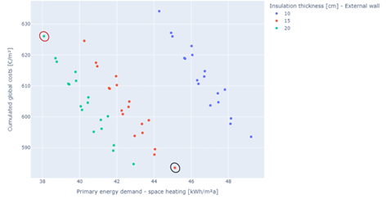

Figure 1. Cost-effectiveness variants of single-stage renovation

Finally, the Figure 2 shows the results of the cumulated primary energy demand (kWh/m²) and global costs (€/m²) over the period of 30 years, taking into consideration the optimized time and the primary energy demand calculated per step. In addition to the results for the 54 variants, the Figure 2 also shows for the cost-optimal variant (ID20) from Figure 1, different single stage renovation scenarios. The scenarios consider that the single stage renovation is carried out immediately (year 0), in year 5, 10, 15 and 20. In general the results show that, in the single-stage approach, as faster the renovation is performed, the lower the global costs and cumulated primary energy demand. When comparing to the staged renovation, the variants are, in terms of cumulated primary energy demand, equivalent to the single stage performed in year 5 (about 3.000 kWh/m²). However, in terms of globals costs, they can vary between 700 €/m² (single-stage year 5) and 850 €/m² (single stage year 15). The cost optimal variant is similar in both single stage and staged approaches, having the staged renovation a slightly higher (about 50 €/m²) global costs.
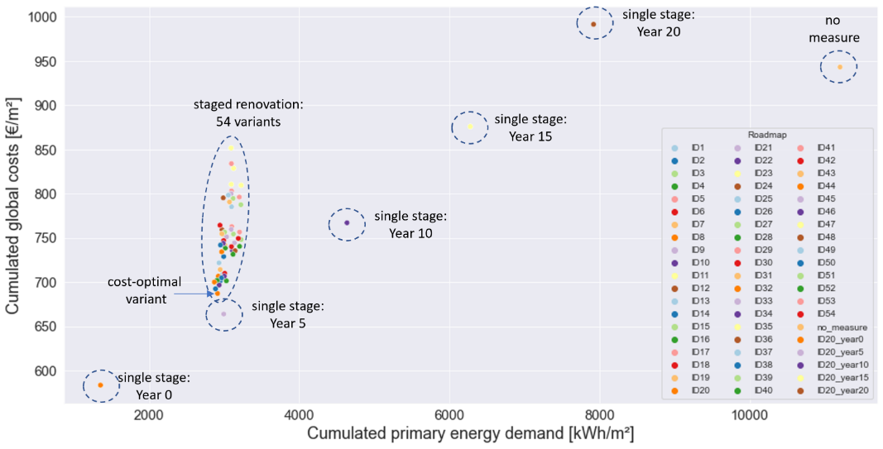

Figure 2. Cumulated primary energy demand and global costs

Literature
[1] European Commission, “A Renovation Wave for Europe - greening our buildings, creating jobs, improving lives.” Oct. 29, 2020, [Online]. Available: https://ec.europa.eu/energy/sites/ener/files/eu_renovation_wave_strategy.pdf.
[2] European Parliament, Directive (EU) 2018/844 of the European Parliament and of the Council of 30 May 2018 amending Directive 2010/31/EU on the energy performance of buildings and Directive 2012/27/EU on energy efficiency (Text with EEA relevance), vol. OJ L. 2018.
[3] I. Maia, L. Kranzl, and A. Müller, “New step-by-step retrofitting model for delivering optimum timing,” Appl. Energy, vol. 290, p. 116714, Aug. 2021, doi: 10.1016/j.apenergy.2021.116714.

Gußhausstraße 25-29/370-3, +43 (0) 1 58801 370380, maia@eeg.tuwien.ac.at

