A NEW MARKET DESIGN for COMPETITIVE, SUSTAINABLE AND democratic ELECTRICITY SYSTEMS

Reinhard HAAS
Energy Economics Group, Vienna University of Technology, E-mail: haas@eeg.tuwien.ac.at

Overview
Currently, the electricity system in many countries is undergoing significant changes. The following issues are important in this context: (i) More and more customers become interested in contributing to their own electricity supply and to switch to “prosumagers”. (ii) This was supported especially by the emergence of decentrally applicable technologies such as PV, small CHP and accompanying use of battery storage; (iii) These developments lead on the systems side to a need for “back-up” capacity (incl. storage) and demand-side flexibility; (iv) Regarding competition in the retail and wholesale markets volatile price structures endanger the stability of the presence of companies, e.g due to high prices in some European countries in recent months many retail companies went bankrupt; (v) Finally a new tariff system for end users is needed reflecting the value of energy and power feeded in and taken out of the grid at every point of time.
This process is currently under way in many countries e.g. Germany, Austria, UK and California. And in these countries also a change in the principle how prices come about is already under way. A major reason for this development is that in recent years the electricity generation from variable renewable energy sources (VRES) especially from wind and photovoltaic (PV) power plants increased considerably.
The major objective of this paper is to analyze and provide insights on how to bring about a competitive, sustainable and demeoctratic electricity system with even higher shares of VRES in an economically balanced system but without escalating political interventions. It is triggered by the current discussion on how to integrate large shares of variable RES but the fundamental intention goes beyond that. It is to show how to head towards real competition in electricity systems, including all dimensions such as generation, storage, but especially the customer side. This is a challenge for all countries world-wide.

Method

Our method of approach is based on the following principles: (i) Crucial is coverage of residual load (= difference between final electricity demand and generation provided by non-flexible electricity generation) ; this is modeled on an hourly base over a calendar year based on assumed variable RES generation and development of the load profile; (ii) Deduction of available conventional and backup capacities including must-run (iii); consideration of flexibility on the demand side based on consumer behavior incl. flexibility instrument such as batteries etc.; (iv) hourly electricity prices equal to short-term marginal costs and scarcity rents.

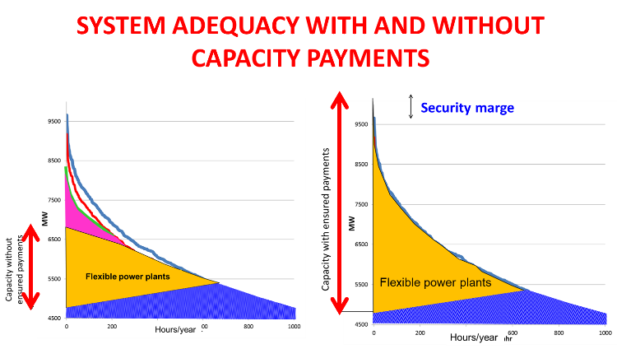 | 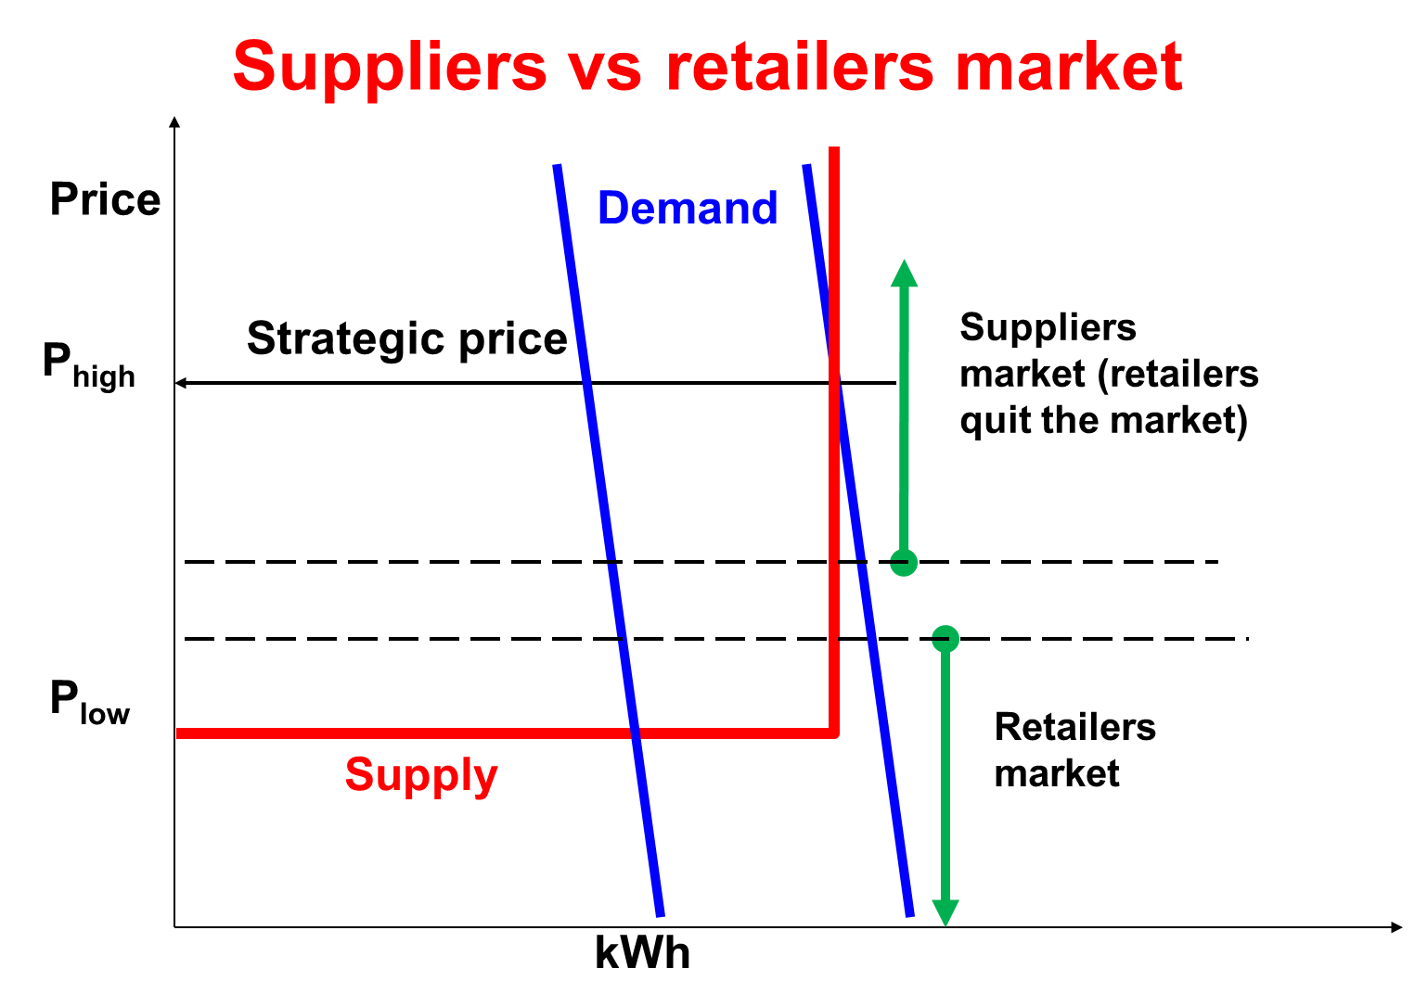
Fig. 1. System adequacy and role of flexible power plants with and without regulated capacity payments | Fig. 2. Suppliers vs retailers markets in the electricity system

Results
The major results are:
- Of core relevance for a complete markets and to enhance competition is a pricing system in an energy-only market where the price signals provide information about scarcity or excess capacities at every point-of-time;
- Most important to balance variations in residual load is a portfolio of flexibility options such as: (i) Battery, pumped hydro and other storage; (ii) Technical demand-side management; (iii) Demand response due to time-of-use pricing.
- However, flexible power plants for capacity system adequacy will play a role in every system with and without regulated capacity payments, see Fig. 1.
- It has to be born in mind that depending on the prive levels in the wholesale markets the incentives for retailers and generators are different. Fig. 2 depicts suppliers vs retailers markets in the electricity system. Retailers are “long” if the market prices are low but they are short and may exit the markets if market prices are high. The situation for generators/suppliers is vice versa.
- A very important aspect is to provide the right price signals for final customers by implementing a bidirectional tariff system for separated components for energy and power, see Fig. 3.
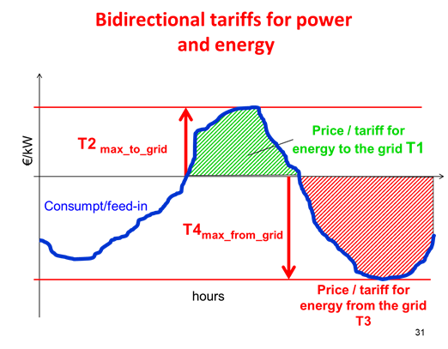 | 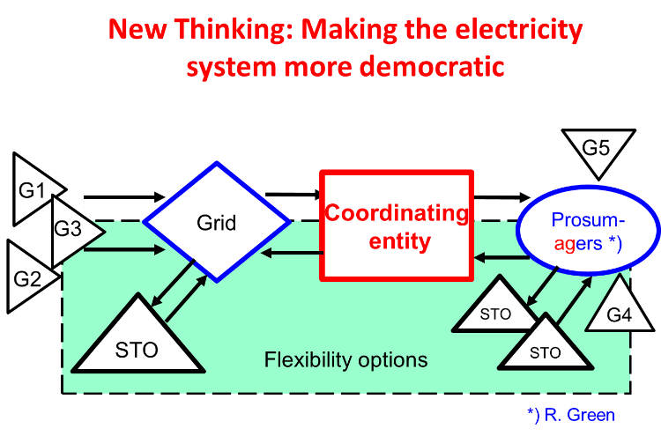
Fig. 3. A bidirectional tariff system with separated components for energy and power | Fig. 4. New thinking in electricity markets: two-way, high flexibility and increasing relevance of „Prosumagers“

Another major finding is that in a complete market there will be a new core player in the chain, the “coordinating entity” which maybe a balancing group or a supplier, see Fig. 4. This player is the logical market coordinator of the electricity supply chain and the organizer of competition between the different options. Finally we state that the transition towards a competitive and sustainable future electricity system will be based on the following principle of “new thinking”, which is to accept a paradigm shift of the whole electricity system - including switching from an inflexible and one-way system where variable load is met with changes in generation to a more flexible and smarter system allowing two-way electricity flows – to our understanding – a greater scope for demand participation by consumers needs to be included.

Conclusions
Our major conclusions are:
- Revised Energy-only-markets have to be introduced which allow temporarily shortage prices higher than short-term marginal costs and in times of excess electricity negative prices;
- A very important element of such a market will be flexibility options. But these will only be harvested when sufficiently high price signals from the electricity markets trigger these options, when “the exploration principle in the markets work”. Yet this will only be done if the market is not distorted by centralized capacity payments.
- Regarding the market structures of companies there is a responsibility of the regulator especially at the retail level. Retail companies without any own assets may exit the markets if market prices are high and leave their customers “in the desert”. This has to be avoided by the regulatory authority.
- Finally, it is important to provide the right price signals for final customers by implementing a bidirectional tariff system for separated components for energy and power.
- The final conclusion of this analysis is, that it will be necessary to accept a paradigm shift in our understanding of the whole electricity system where no longer the generators are the centre but coordinating entities such as balancing groups respectively the supply companies. And finally we state that the evolution of such a creative system of integration of RES in Western Europe may also serve as a role model for electricity supply systems largely based on RES in other countries world-wide.

