Steel, ammonia, green H₂ and CO₂ – a pack of cards to create industrial symbiosis options in Upper Austria
Themenbereich: (5) Dekarbonisierung: Industriesektor

Valerie RODIN⁽¹⁾, Johannes LINDORFER⁽¹⁾, Andreas ZAUNER⁽¹⁾, Oliver MAIER⁽²⁾
⁽¹⁾ Abteilung Energietechnik, Energieinstitut an der Johannes Kepler Universität Linz
⁽²⁾ K1MET GmbH

Motivation and Central Questions
The EU foresees circular economy [1] approaches as a building brick to transform the European industry in a sustainable way. New value chains, utilizing alternative resources, are needed to sustain fundamental industrial sectors. Among these are the steel and fertilizer industries, which are important economic players in Austria. As green hydrogen is at the heart of their transition processes, joint questions rise, such as which amounts can be produced locally from green electricity and which alternatives to on-site production are feasible in the long-term.

Method
In Linz, steel and fertilizer companies operate fence-to-fence, facing similar challenges but also opportunities: Crude steel production is a great CO₂ emitter and will need renewable hydrogen as reducing agent in the future [2]. For ammonia, hydrogen from natural gas is a key resource, in the future it also needs to be replaced by green hydrogen [3]. Furthermore, urea production is a large-scale CO₂ consumer [4] – also a resource that is currently produced via steam reforming, thus, alternative CO₂ sources need to be tapped. In the EU H2020 funded project CORALIS [5], different industrial symbiosis options for the Linz industrial site are assessed. For this, a stepwise approach was followed, consisting of individual interviews with and mediated discussions of the industrial players, process simulations and technoeconomic assessments. The goal was to narrow down a potpourri of synergy opportunities based on their technoeconomic feasibility and long-term sustainability in order to identify realizable solutions and open research questions. This industrial symbiosis development process is accompanied by research entities, which act as neutral facilitators.

Results and Conclusion
Seven industrial symbiosis options were defined, analyzed and discussed over 18 months. In 13 meetings, opportunities were identified, technical challenges and open questions clarified.

- Renewable H₂ exchange from existing water electrolyzer and import
- Methanation of CO₂
- Methanation of steel plant off-gases
- Utilization from coke oven gas for H₂ supply
- Ammonia as H₂ storage and reconversion on demand
- CO₂ for urea production
- Process integration of existing and potential new assets

The objective was to create a win-win situation for the industrial players while driving their transition to sustainable production processes. The use cases were assessed in different levels of detail by all participants. While initially CO₂ was in the focus for a local “carbon cycle”, in course of the process the long-term perspective shifted towards shared local hydrogen production and cooperation on hydrogen import options for a fully decarbonized steel and ammonia industry. The future focus is on a joint road-mapping process, in order to enable the development of business models and detailing of process adaptions with focus on green hydrogen. Furthermore, the identification of further synergy opportunities will be traced, such as waste heat utilization, further stakeholder involvement and technical cooperation planning needs.

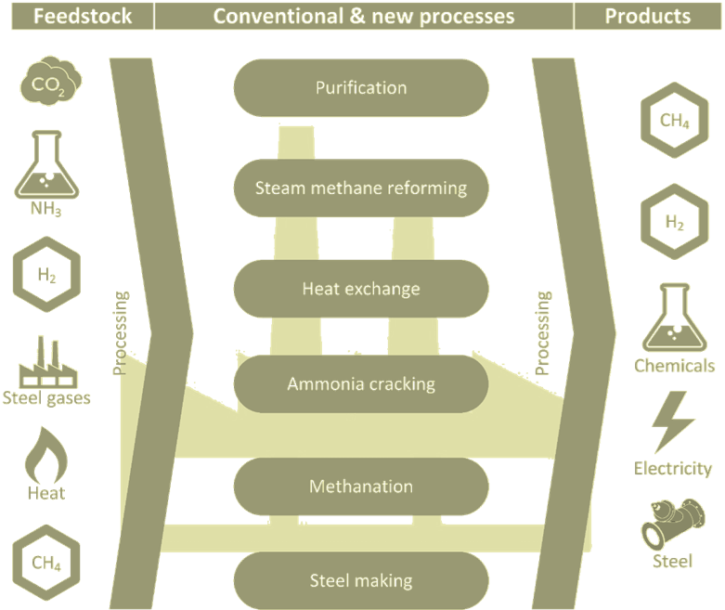
Figure 1: Available feedstocks and potential products of industrial symbiosis options at the industrial site in focus. Source: Energieinstitut an JKU Linz.

This project has received funding from the European Union’s Horizon 2020 research and innovation program under Grant Agreement No 958337.

Literature
[1] European Commission, ‘Circular Economy Action Plan #EUGreenDeal’, 2020. Accessed: Feb. 04, 2022. [Online]. Available: https://ec.europa.eu/environment/pdf/circular-economy/new_circular_economy_action_plan.pdf
[2] M. Draxler, J. Schenk, T. Bürgler, and A. Sormann, ‘The Steel Industry in the European Union on the Crossroad to Carbon Lean Production—Status, Initiatives and Challenges’, Berg Huettenmaenn Monatsh, vol. 165, no. 5, pp. 221–226, May 2020, doi: 10.1007/s00501-020-00975-2.
[3] D. R. MacFarlane et al., ‘A Roadmap to the Ammonia Economy’, Joule, vol. 4, no. 6, pp. 1186–1205, Jun. 2020, doi: 10.1016/j.joule.2020.04.004.
[4] International Energy Agency (IEA), ‘Putting CO2 to Use - Creating value from emissions’, Sep. 2019. Accessed: Oct. 31, 2022. [Online]. Available: https://www.iea.org/reports/putting-co2-to-use
[5] CORALIS, ‘CORALIS | project homepage’, CORALIS, 2022. https://www.coralis-h2020.eu/ (accessed Oct. 31, 2022).

Altenbergerstraße 69, 4040 Linz, +43 (0) 732 / 2468 5671, rodin@energieinstitut-linz.at, www.energieinstitut-linz.at

