Development of electric passenger cars during the COVID-crisis
Themenbereich: (6) Dekarbonisierung: Verkehrssektor

Amela Ajanovic
TU WIEN, Energy Economics Group

Motivation and core objective
The COVID-crisis has affected all segments of our life, especially our mobility. The transport sector was one of the most affected sectors due to the imposed restrictions to the most of transport modes, what has resulted in significant change in our behavior. Major new trends were teleworking and the preferable use of private mobility, especially active mobility.
Already in the first months of the crisis, it was clear that development of e-mobility could be affected due to the restrictions and interruptions in supply of batteries and other relevant parts for auto industry, which are imported mostly from China. Moreover, due to the reduced total economic activity, there was the treat that electric vehicles, which deployment is still very dependent on supporting policies, will become less attractive.

The core objective of this paper is to discuss the impact of the COVID-19 crisis on the electrification of passenger car mobility.

Method of approach
In this paper, at first, is analyzed the development of e-mobility before the COVID- crisis including global stock of electric vehicles, as well as electric vehicle use in the EU Member States. In addition, major relevant supporting policies and targets are documented.

Moreover, environmental and economic developments are analyzed considering carbon intensity of electricity mix and battery price reductions (Fig.1), respectively.

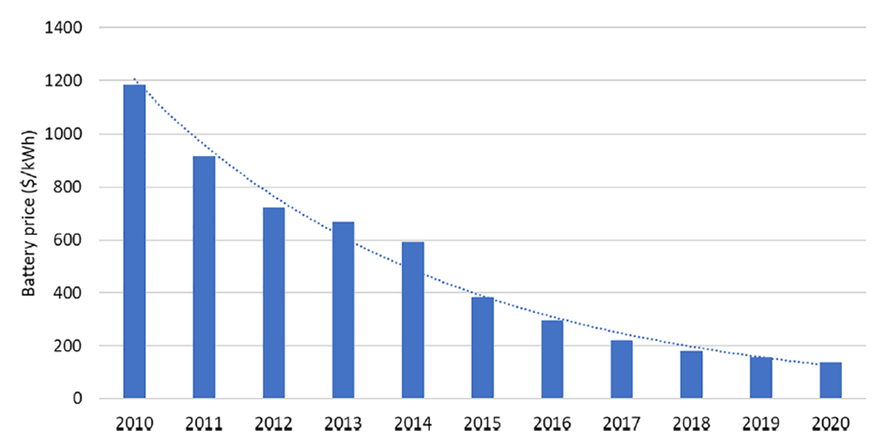

Figure 1. Volume-weighted battery pack prices (Data sources: [1,2])

Results and conclusions
Due to the COVID-crisis the relatively good progress in electrification was temporarily stopped in the beginning of 2020. Major reasons were supply restrictions for the car industry, which is very dependent on imported components and raw materials, and the behavioral changes made during the crisis, such as social distancing and travel limitations.
Although, electric vehicle industry was very affected due to interruptions in the supply chains and production, in opposite to first expectations, total electric vehicle sale have increased in the major electric vehicle market in 2020 comparing to 2019, see Fig. 2. Due to very generous purchase incentives and regulatory instruments, especially high increase in electric vehicle sale was in Europe, about 130%.

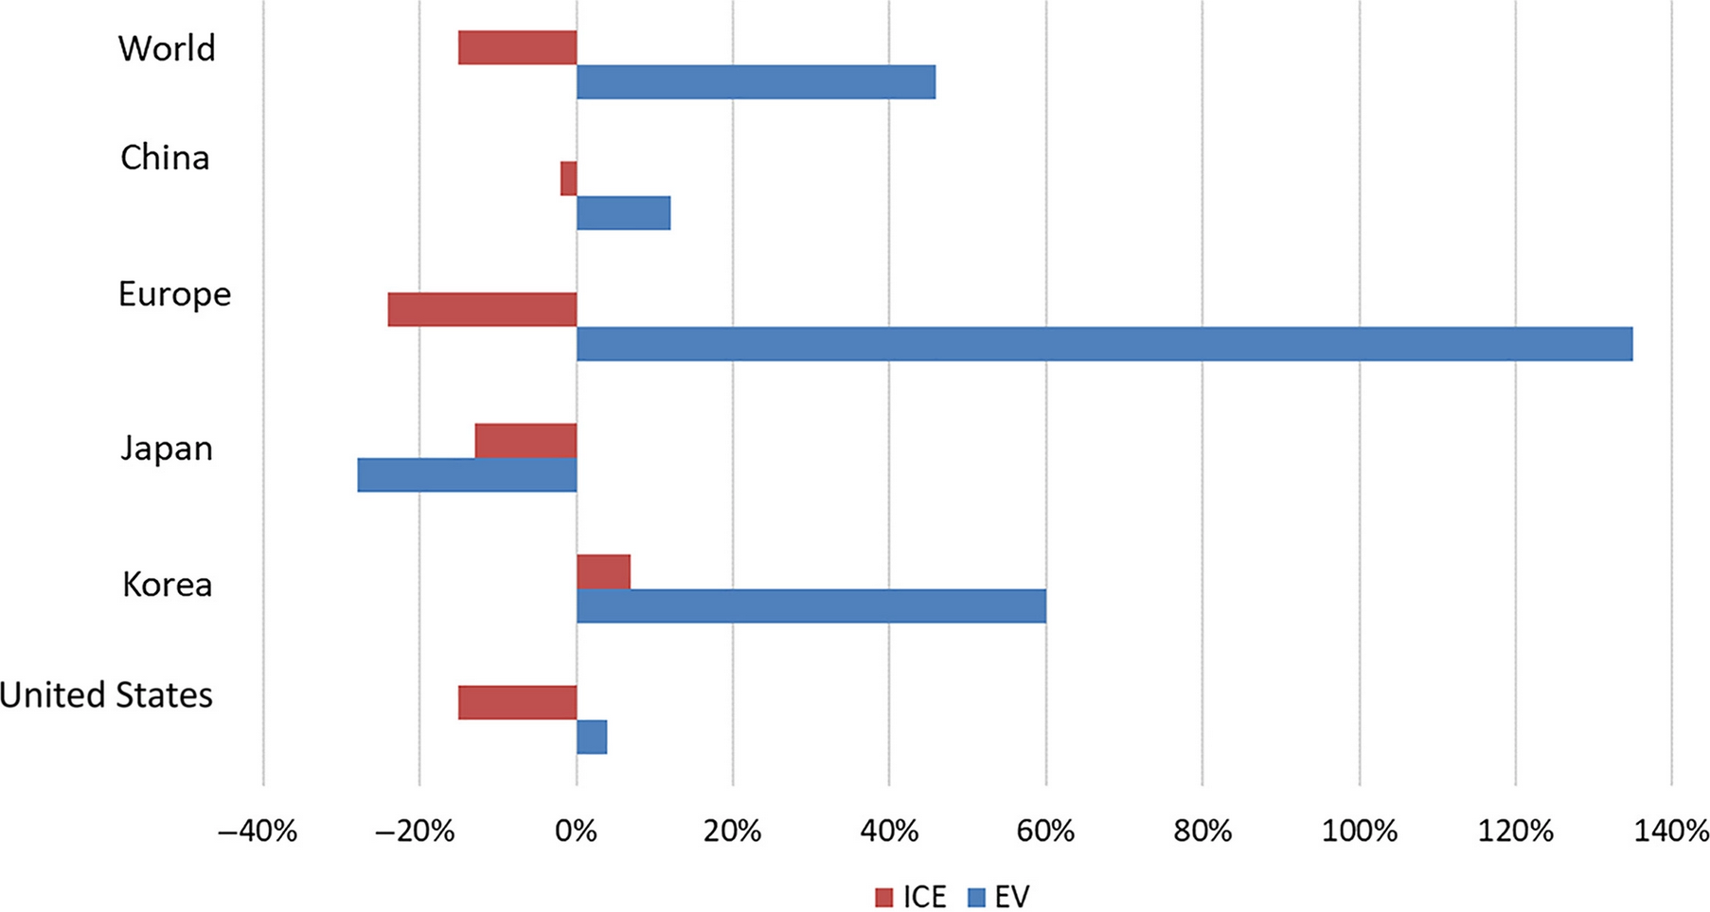

Figure 2. Increases and decreases in total car and electric car sales in selected countries/regions in 2020 in relation to 2019 (Data sources:[3])

However, the largest number of electric vehicle sale in the EU, as well as the largest investment in the charging infrastructure, is concentrated in just few Member States with the highest GDP.
In addition, since most of the supporting measures for electric vehicles will be abolished with their increasing number, new policy design is needed which should ensure increasing use of green energy in electric vehicles.

References
[1] BloombergNEF. (2020). Battery pack prices cited below $100/kWh for the first time in 2020, while market average sits at $137/kWh. https://about.bnef.com/blog/battery-pack-prices-cited-below-100-kwh-for-the-first-time-in-2020-while-market-average-sits-at-137-kwh/
[2] WinAck. (2022). Lithium ion battery pack prices decrease year by year. https://www.winackbattery.com/news/lithium-ion-battery-pack-price.html
[3] International Energy Agency (IEA). (2020b). How global electric car sales defied Covid-19 in 2020. https://www.iea.org/commentaries/howglobal-electric-car-sales-defied-covid-19-in-2020
[4] Ajanovic A. (2022). The impact of COVID-19 on the market prospects of electric passenger cars. WIREs Energy Environ. 2022;11:e451. https://doi.org/10.1002/wene.451

