Seasonal hydrogen storage in different renewable electricity scenarios in the Austrian power system
Sector coupling and flexibility
Marlene SAYER, Reinhard HAAS, Amela AJANOVIC
^{(1,2,3)} Energy Economics Group, Vienna University of Technology

Motivation and research question
The existing energy system is facing the major challenge of transitioning from a largely fossil-based system to a renewable one. In this context electricity generation together with demand patterns will change substantially due to the variability of wind and solar production and electrification in certain sectors such as the transport sector.
In Austria in particular, with the “Renewable Expansion Law (EAG)” the concrete target of 100 % on-balance renewable electricity in 2030 was set, implying that wind and solar will shape the additional generation capacities. Therefore, it is also becoming increasingly important to integrate seasonal storage into the power grid in order to shift excess electricity production in the summer to the winter for use, see Figure 1. Within the project “Underground Sun Storage 2030”, a seasonal hydrogen storage solution in a depleted natural gas reservoir will be developed and tested. Figure 2 shows the process of renewable hydrogen production, storage to re-electrification including the respective efficiencies. As part of this project, this work attempts to determine the need for seasonal hydrogen storage in the future power system.

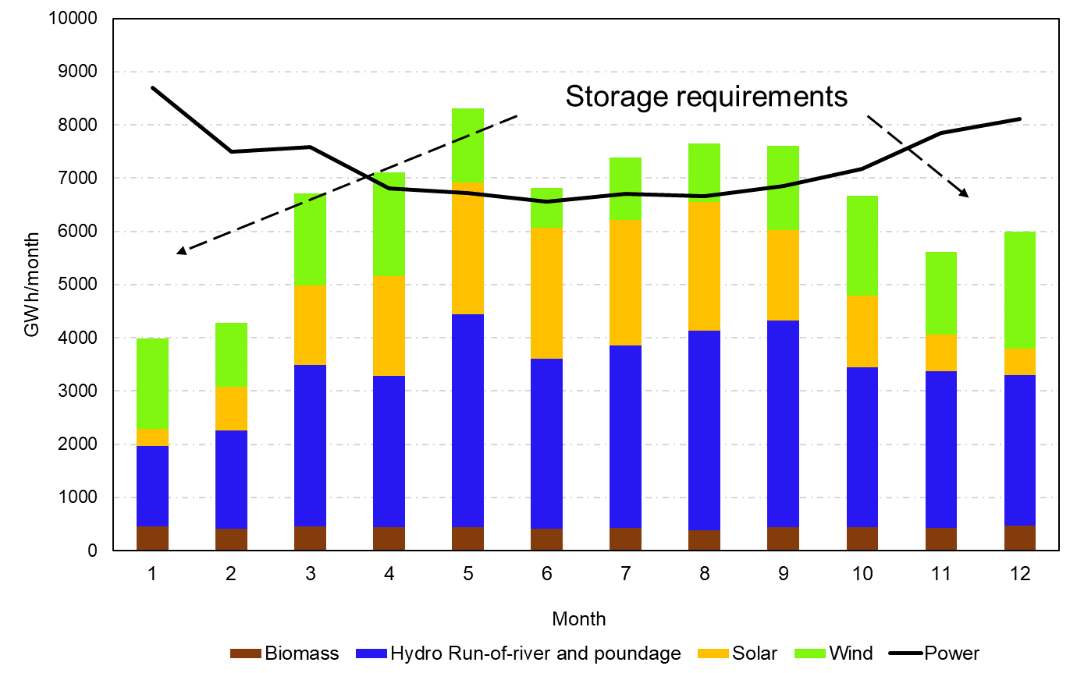 | 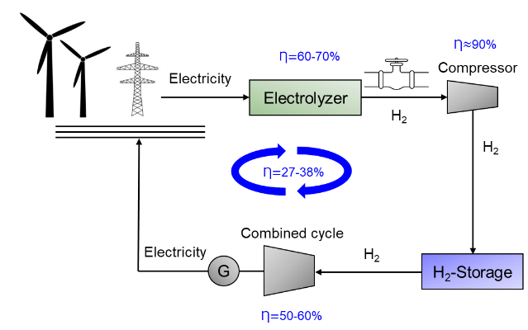
Fig. 1. Monthly electricity generation from variable RES and the respective load in 2030 for the example of Austria according to EAG targets | Fig. 2. Efficiencies of hydrogen storage and re-electrification

Methodology
Our approach is based on: (i) an hourly model of the Austrian electricity system for different renewable expansion targets and demand scenarios; (ii) an analysis of the residual hourly load and hence required storage capacity and possible surplus renewable electricity over a calendar year resulting from the defined generation and demand scenarios, see Figure 3 and 4; (iii) a literature review on techno-economic analysis of hydrogen storage including efficiencies analysis of the storage chain.

$\min{\sum_{t=1}^{8760}{P_{i/j }(t)*c_{i/j}}}(t)$ (€) (1)
with
P Power plant capacity (MW) i Power plant
j Storage plant t Point in time
X Climate year (X=1:3), 3 years c Variable cost (€/MW)

subject to
$P_{total}(t)= P_{RE}(t)$ ${+ P}_{bio}(t)$ $- P_{pump}(t)$ ${\text{+} P_{turb, PSH }(t)\text{+} P_{turb, SH}(t)-P_{P2G,H2}(t)+P}_{CCGT,H2}(t)$ ${+ P}_{CCGT,bio}(t) -$ $P_{export}(t)$ + $P_{import }(t){- P}_{over}(t)$ + $P_{under}(t)$ (MW) (2)
P_{total} Total power available (MW) P_{RE} Power of renewable energy (MW)
PSH Pumped storage hydropower SH Storage hydropower
P2G Power-to-gas H₂ Hydrogen
CCGT Combined cycle gas turbine

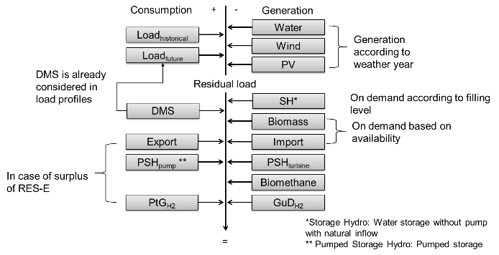 | 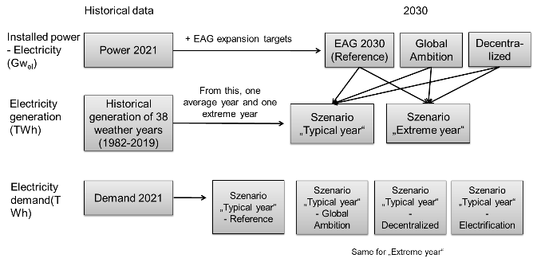
Fig. 3. Schematic model structure | Fig. 4. Scenario design

Results and conclusions
Hydrogen storage will become an essential part of a fully renewable energy system in the future. The type of storage will be different depending on the geological conditions. Recent studies show that on a large scale, subsurface storage will be the prevailing technology [1]. Gaseous hydrogen storage in salt caverns, for example, is already in use on an industrial scale [2]. While storage in depleted gas reservoirs, as is the case in Austria, is in an earlier phase, it is according to Chen [3] the most cost-effective technology among depleted gas reservoirs, salt caverns, and saline aquifers.

Increasingly renewable generation and the resulting low cost of electricity generation, including surpluses, will make hydrogen storage more affordable. The analysis shows which quantities of hydrogen have to be stored seasonally to serve different renewable energy generation as well as demand scenarios. Furthermore, the amount of surplus renewable electricity that can be utilized for hydrogen production in different weather years will be indicated. From today's perspective, the biggest problems in the transition to a hydrogen economy are the high costs of green hydrogen production, transport and storage, and also conversion technologies. Furthermore, the low efficiencies of the mentioned processes are another problem.

Literature
[1] M. Lysyy, M. Fernø, and G. Ersland, “Seasonal hydrogen storage in a depleted oil and gas field,” International Journal of Hydrogen Energy, vol. 46, no. 49, pp. 25160–25174, Jan. 2021, doi: 10.1016/j.ijhydene.2021.05.030.
[2] J. Andersson and S. Grönkvist, “Large-scale storage of hydrogen,” International Journal of Hydrogen Energy, vol. 44, no. 23, pp. 11901–11919, May 2019, doi: 10.1016/j.ijhydene.2019.03.063.
[3] F. Chen, Z. Ma, H. Nasrabadi, B. Chen, and J. W. V. Wijk, “Technical and Economic Feasibility Analysis of Underground Hydrogen Storage: A Case Study in Intermountain-West Region USA,” p. 25, 2022.

The work is part of the project "Underground Sun Storage 2030". It is part of the energy showcase region WIVA P&G and an important step for the development of a secure hydrogen economy. The project is funded under the Energy Research Program of the Austrian Climate and Energy Fund.

Gusshausstraße 25/E370-3, 1040 Wien, +43(0)-1-58801-370333, sayer@eeg.tuwien.ac.at, http://eeg.tuwien.ac.at/

