Smart Microgrids as a Service: Development and Evaluation of User-Centric Business Models for Energy Communities
Themenbereich: (4) Aktive Endkunden- / Prosumerpartizipation & Gebäudesektor
Saskia Bluhm, Armin Golla, Sarah Henni, Christof Weinhardt
Karlsruhe Institute of Technology

Motivation and Central Question
Energy communities, in which neighbors participate in joint generation and investment in renewable energy, offer the opportunity to accelerate the energy transition, assuming effective regulation [1]. More than 90% of all German households are eligible for energy sharing [2]. However, the practical implementation of energy communities is fraught with challenges when it comes to developing viable business models and involving local stakeholders beyond energy sharing. In this study, we present the results of an extensive expert survey on user-centric business models for energy communities. The study has been conducted as part of the research project “Smart Microgrids as a Service”.

Methodological Approach
Previous energy community concepts often focus on a peer-to-peer trading with active customer participation [3], but research has shown that user interaction decreases over time [4], as expected for a low-involvement product like energy. Therefore, the identification and evaluation of suitable business models tailored to the context of energy communities is necessary. Using a comprehensive literature review, we identified five potential business models for energy communities: Aggregating flexibility of private households (Flex), peer-to-peer trading in energy communities (P2P), collective investment in renewable energy appliances (Invest), operative leasing of appliances (Lease) and energy-as-a-service (EaaS). To assess the potential of these business models, we conducted an expert survey with 40 industry experts. The expert pool consisted mainly of senior executives working for energy utilities (47,5%), distribution system operators (15%), transmission system operators (7,5%), research institutions (7,5%) or other companies in the energy sector (22,5%). The business models were rated by the experts on 5-point Likert scales in eleven categories, including perceived and actual potential for cost savings to customers, positive impact on emissions savings, fostering community spirit and adding value to society, availability of technological requirements, increasing energy self-sufficiency, and feasibility of the business model from a provider’s perspective.

Results and Conclusions
While the experts expect all business models to have a positive impact on the expansion of renewable energy and the reduction of carbon emissions, they see a need for action on the technical requirements for the Flex and P2P business models (see Figure 1). Both require specific hardware, particularly smart meters, to enable widespread implementation in practice. In addition, the majority of experts expect financial savings for customers in all business models except for the Lease business model (Figure 2). The highest monetary incentives or cost reductions are anticipated from the Invest business model ($μ=3.531, σ=1$; 5-point Likert scale). While the ecological advantage is rated as positive for all business models, the benefits generated by the business models from a provider’s perspective are assessed more critically in general. Only in the case of Lease and EaaS, most experts agree or completely agree that the business models are potentially lucrative; Flex and P2P are viewed most critically in this regard. Finally, for an overall assessment of the business models a weighted score is derived, excluding items having a low correlation to the overall scale. In this overall assessment, the Invest ($μ=3.53$) business model performs best, while Lease receives the lowest score.

Literatur
- Golla, Armin; Röhrig, Nicole; Staudt, Philipp; Weinhardt, Christof (2022): Evaluating the impact of regulation on the path of electrification in Citizen Energy Communities with prosumer investment. In: Applied Energy 319, S. 119241. DOI: 10.1016/j.apenergy.2022.119241.
- Wiesenthal, Jan; Aretz, Astrid; Ouanes, Nesrine; Petrick, Kristian (2022): Energy Sharing: Eine Potenzialanalyse. Institut für ökologische Wirtschaftsforschung (IÖW). Berlin.
- Ableitner, Liliane; Tiefenbeck, Verena; Meeuw, Arne; Wörner, Anselma; Fleisch, Elgar; Wortmann, Felix (2020): User behavior in a real-world peer-to-peer electricity market. In: Applied Energy 270, S. 115061. DOI: 10.1016/j.apenergy.2020.115061.
- Richter, Bent; Staudt, Philipp; Weinhardt, Christof (2022): Citizen Energy Communities - Insights Into Long-Term Participant Behavior From a Field Study.

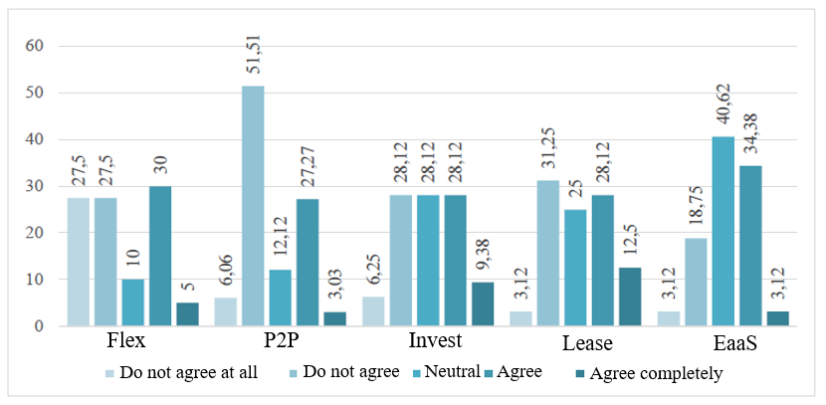
Figure 1: Expert answers to Item 8: "It is possible to offer the business model on the market, since enough potential customers have the necessary technical requirements." (Numbers in percent)

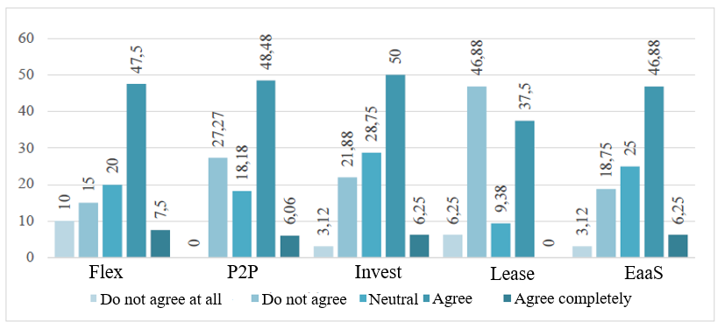
Figure 2: Expert answers to Item 1: "The business model is expected to generate significant
cost savings or other financial incentives for customers." (Numbers in percent)

Jungautorin, Kaiserstraße 89, 76133 Karlsruhe, +49721608-48377, saskia.bluhm@kit.edu, im.iism.kit.edu

