Hydrogen sector coupling of Innere Stadt Linz
Sector coupling and flexibility
Iskandar Zeynalov, Erwin K. Reichel, Horst Steinmüller
WIVA P&G, Magazingasse 7, 4020 Linz
Motivation and central question
Climate change, urbanization trends, and increased demands on residents' living standards necessitates a response from city planning regarding energy generation, supply, and consumption.
Because of an increasing number of renewable energy sources, the volatility of sources impacts the requirements of the overall energy system.
Short-term load balancing and long-term seasonal storage is necessary to achieve the decarbonization of the power sector. These capacities, however, are spatially constrained, making the need for alternative flexibility strategies like gas storage necessary.
Sector coupling or sector integration mean strategies to maximize the efficient use of energy by optimizing the overall energy system instead of, e.g., considering the gas, heat, and electricity grid separately. Power-to-gas (PtG) nodes and efficient reconversion enables the integration of renewable electricity sources with the goal to replace fossil fuels.
Methodological approach
Via the City Energy Analyst (CEA) software, the demand and other estimations were collected and used to calculate CO2 reductions and storage requirements. It makes use of a large database and common estimates to calculate the energy demand of buildings with a temporal resolution of 1 hour in 1 year.
First, the area is defined to include specific buildings. Then each of the buildings is assigned to the archetypical type like school, office, store etc. to have a better estimation of the energy use. Then the schedule is defined, and weather conditions are taken from the database. After running the radiation script, the solar energy gains are also considered and used for further calculations. After getting the amount of energy demand, the round-trip efficiency of hydrogen was calculated. Only knowing that we can estimate the real amount of energy necessary to input into the system. Then, we got the information about non-biogenic (fossil) CO2 emissions per kWh from district heating organization and used it for calculations. In current hypothesis the hydrogen technology is used in district heating to generate heat and then distribute it to the consumers. However, the indoor fuel cell usage coupled with heat pumps is a viable option.
For the total sector coupling, we need to consider all the energy demand of 3000 buildings in Innere Stadt and assume generation with python code to find an approximate storage capacity. The idea is simple: find the difference between consumption and generation and plot the graph of the difference, which will specify the amount of energy stored.
Results and conclusions
The reviewed model consisted of 3000 real buildings equipped with hypothetical solar photovoltaic modules on their roofs, and the panels are South-facing with 30 degree of tilt angle.
The final results of this project are the achievable reduction of CO2 by 58414 tons with a need of 422000 cubic meters of storage at 100 bar pressure. Additionally, the solar photovoltaic panels on the roof of every building reduce the demand for space heating energy by 13.7%, by increasing the excess amount of green energy to use for hydrogen production, further pushing the idea of generating renewable energy on every building.
Additionally, in future development, it would be useful to experiment with different configurations of buildings and the ratio of solar PV and thermal installations, as well as the project sizes because the initial idea was to simulate all the buildings in Linz, which are 45000. However, the hardware available for that wasn't powerful enough to do it in an adequate amount of time.
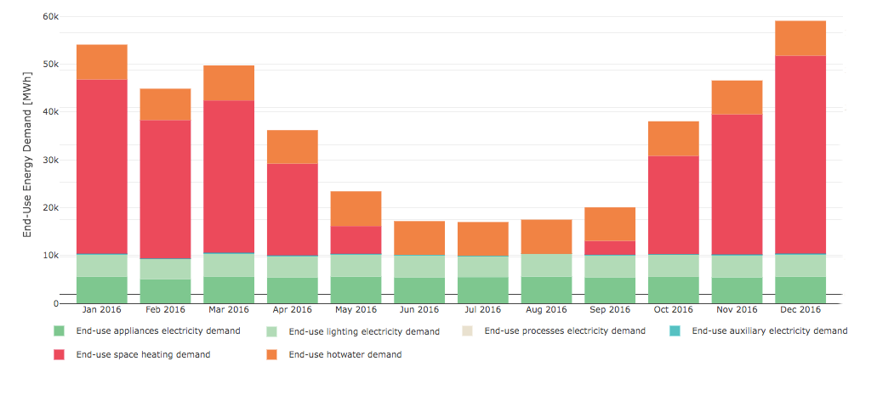
Figure 1: End-Use Energy Demand of buildings in Innere Stadt, Linz

Literature

[1] UNFCCC. COP26 world leaders summit- statement on the breakthrough agenda”, UN Climate Change Conference UK 2021, United Nations Framework Convention on Climate Change, https://ukcop26.org/cop26-world-leaders-summit-statement-on-the-breakthrough-ag. UK.
[2] IPCC. Climate Change 2021: The Physical Science Basis. Contribution of Working Group I to the Sixth Assessment Report of the Intergovernmental Panel on Climate Change. 2021.
[3] IEA. The Future of Hydrogen: Seizing today’s opportunities. 2019a. Paris.
77 | P a g e
[4] Bauer, C. et al. On the climate impacts of blue hydrogen production. 2021. https://doi.org/10.33774/CHEMRXIV-2021-HZ0QP.
[5] Howarth, R.W. and M.Z. Jacobson. “How green is blue hydrogen?” Energy Science & Engineering, 2021, https://doi.org/10.1002/ESE3.956. pp. 1676-1687 Vol. 9, Issue 10.
[6] IRENA. Green Hydrogen: A Guide to Policy Making, IRENA 2020b. Abu Dhabi.
[7] Saunois, M. et al. “The global methane budget 2000-2012”, Earth System Science Data, 2016, https://doi.org/10.5194/essd-8-697-2016. pp. 697–751 Vol. 8, No. 2.
[8] Philibert, C. Renewable Energy for Industry: From Green Energy to Green Materials and Fuels, IEA Insights Series, 2017, OECD/IEA, https://iea.blob.core.windows.net/assets/48356f8e-77a7-49b8-87de-87326a862a9a/Insights_series_2017_Renewable_Energy_for_Industry.pdf. Paris.
[9] IRENA. Green Hydrogen Cost Reduction: Scaling up Electrolysers to Meet the 1.5⁰C Climate Goal, IRENA 2020a. Abu Dhabi.
[10] Fraunhofer ISE. “HySpeedInnovation: A joint action plan for innovation and upscaling in the field of water electrolysis technology”, 2020, www.ise.fraunhofer.de/content/dam/ise/en/documents/News/Position-Paper-HySpeedInnovation.pdf.

