Selection and Evaluation of Generation-Storage Portfolios for Partially Self-Sufficient Energy Municipalities
Themenbereich 2: Energieerzeugung/-infrastruktur und Netze
Hubertus VON HÜLSEN ⁽¹⁾, Reinhard MADLENER ⁽²⁾
⁽¹⁾RWTH Aachen University, ⁽²⁾ Institute for Future Energy Consumer Needs and Behavior (FCN), School of Business and Economics / E.ON Energy Research Center, RWTH Aachen University

Motivation and Key Question
In this paper a techno-economic model for analyzing power generation and storage investment portfolios of municipalities is developed, enabling to identify predefined self-sufficiency objectives. The main idea behind the model is to find the combinations of generation and storage technologies with regard to a self-sufficiency target. This can be achieved in an iterative process by calculating the degree of self-sufficiency for different combinations of generation technologies and varying the storage capacity until the intended degree of self-sufficiency is reached.
Methodical Approach
Mean-Variance Portfolio Theory is applied to determine efficient portfolios of distributed assets. When combining multiple different assets with diverse risk-return profiles Mean Variance Portfolio (MVP) theory can be used to evaluate different portfolios. MVP was originally introduced by Markowitz (Markowitz, 1952) to evaluate financial securities and can be transferred to electricity generation portfolios. The basis for MVP are the risk-return profiles of the different technologies as well as their correlations. The expected return of a portfolio with N different technologies can therefore be calculated by the weighted sum (Awerbuch and Berger, 2003). Net present value and Monte Carlo simulation is used on quarter-hour heat and power generation and load data for the calculation of risk and return.

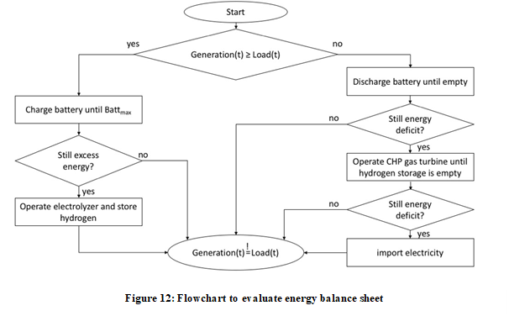
Figure 1: Flowchart to evaluate energy balance sheet

To assess the impacts of the inclusion of a combined heat and power (CHP) gas turbine and the type of compensation for excess energy on the optimal generation-storage portfolios, the following four scenarios will be investigated for the energy municipality: Scenario I: Compensation of excess energy with feed-in tariff, no CHP gas turbine ; Scenario II: Compensation of excess energy with feed-in tariff, CHP gas turbine included; Scenario III: Compensation of excess energy on the market, no CHP gas turbine; Scenario IV: Compensation of excess energy on the market, CHP gas turbine included. For every defined scenario, the investment portfolios of the reference municipality are evaluated with regards to three different self-sufficiency objectives. The results are thereafter evaluated with a sensitivity analysis.
Results and Conclusions
The scenario analysis shows that with hybrid PV/battery storage systems ambitious self-sufficiency targets are mostly not economically viable. Battery storage can help to increase the expected return and reduce the risk for municipalities with high self-sufficiency targets. However, most portfolios that include a large battery storage capacity are not found projectable at current investment costs. When adding a CHP gas turbine and hydrogen storage unit to the portfolio the return is not increased. A heat-driven operation of the gas turbine can increase the capacity factor and render the investment more profitable. Still, heat-driven CHP gas turbines are must-run units that decrease the flexibility. Finally, municipalities with good locations for wind power have a major advantage in terms of profitability, whereas the impact of solar energy is mostly important for those municipalities with ambitious self-sufficiency objectives.

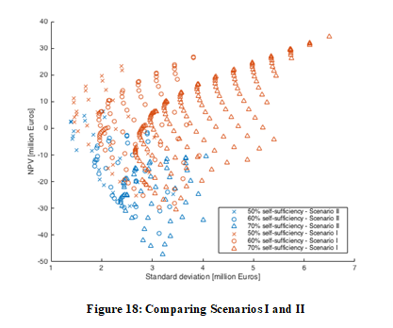
Figure 2: Scenario I (Compensating with FIT, no CHP) vs. Scenario II (Compensating with FIT, with CHP) (left plot) vs. Scenario III (right plot) (Selling on the energy market, no CHP)

References
[1] Awerbuch, S. and Berger, M. (2003), 3 IEA/EET working paper Applying portfolio theory to EU electricity planning and policy-making. [Online] URL: http://www.awerbuch.com/shimonpages/ shimondocs/iea-portfolio.pdf
[2] Koirala, B.P., Koliou, E., Friege, J., Hakvoort, R.A. and Herder, P.M. (2016), Energetic communities for community energy : A review of key issues and trends shaping integrated community energy systems. Renewable and Sustainable Energy Reviews, 56: 722–744.
[3] Kondziella, H., Brod, K., Bruckner, T., Olbert, S. and Mes, F. (2013), Stromspeicher für die Energiewende’’ - eine akteursbasierte Analyse der zusätzlichen Speicherkosten. Zeitschrift für Energiewirtschaft, 37: 249–260.
[4] Markowitz, H.M. (1952), Portfolio selection. The Journal of Finance, 7(60): 77–91.
[5] Menges, R. and Müller-Kirchbauer, J. (2012), Rekommunalisierung versus Neukonzessionierung der Energieversorgung. Zeitschrift für Energiewirtschaft, 36(1): 51–67.
[6] Müller, M.O., Stämpfli, A., Dold, U. and Hammer, T. (2011), Energy autarky : A conceptual framework for sustainable regional development. Energy Policy, 39: 5800–5810.
[7] Späth, P. and Rohracher, H. (2010), ‘Energy regions’: The transformative power of regional discourses on socio-technical futures. Research Policy, 39(4): 449–458.

Mathieustrasse10, 52074 Aachen, Germany, Tel. +49 241 49 820 Email: RMadlener@eonerc.rwth-aachen.de, Web: www.eonerc.rwth-aachen.de.

