Finding realisable & optimal energy systems by coupling simulation and optimisation models
Energiesystem- und Klimamodellierung
Christoph SCHIMECZEK^{(1),*}, Laura TORRALBA-DÍAZ⁽²⁾, Johannes KOCHEMS⁽¹⁾, Felix GUTHOFF⁽²⁾, Kai HUFENDIEK⁽²⁾
⁽¹⁾ Deutsches Zentrum für Luft- und Raumfahrt e.V., Institut für Vernetzte Energiesysteme, Curiestraße 70563, Stuttgart
⁽²⁾ Universität Stuttgart, Institut für Energiewirtschaft und Rationelle Energieanwendung, Heßbrühlstraße 49a, 70565 Stuttgart
* Christoph.Schimeczek@dlr.de

Motivation
Energy system optimisation models are widely used in the field of energy systems analysis. However, these models often assume perfect markets and do not consider real-world market distortions caused by, e.g. regulatory instruments, the behaviour of market actors or their uncertainties. Agent-based simulation models can consider such imperfections, but they cannot identify optimal systems. The difference in the results between these model classes is known as “efficiency gap” [1]. The authors of the associated research project aim at reducing this efficiency gap by integrating restrictions of simulation models into optimisation models [2]. In this way, energy system optima are identified that can be implemented under real-world market conditions, which we refer to as “realisable optima”.
Methodology
We couple the optimising electricity market model E2M2 [3] and the agent-based simulation model AMIRIS [4], which were previously harmonized in [1]. The harmonisation ensures that there are no deviations in model results due to different data bases. Therefore, result differences reliably indicate the efficiency gap. Both models are coupled in a bidirectional way using two iteration loops (see Figure 1).
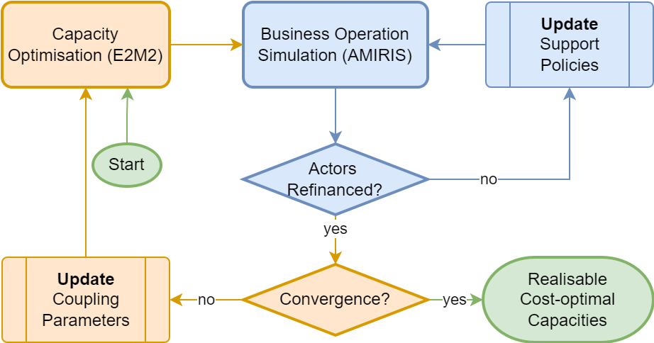
Figure 1: Bidirectional coupling of E2M2 and AMIRIS
Firstly, E2M2 finds a least-cost system for generation capacities and flexibility options. These are then passed to AMIRIS, which simulates the electricity market including actor behaviour, their uncertainties and support schemes. For each market actor, refinancing of its assets is evaluated. In case not all assets are refinanced by market revenues alone, an inner loop (blue) is started to adjust support schemes. This inner loop terminates once every asset is refinanced considering market revenues and support payments. From this final simulation of the inner loop, system parameters are extracted (e.g. electricity costs, CO₂ emissions or unserved demand) and returned to E2M2. Those parameters are used to adjust the next optimisation in the outer loop (orange). This iterative approach should finally converge towards a new cost-minimal system that is realisable, i.e. considers non-ideal market restrictions.
Results and Conclusions
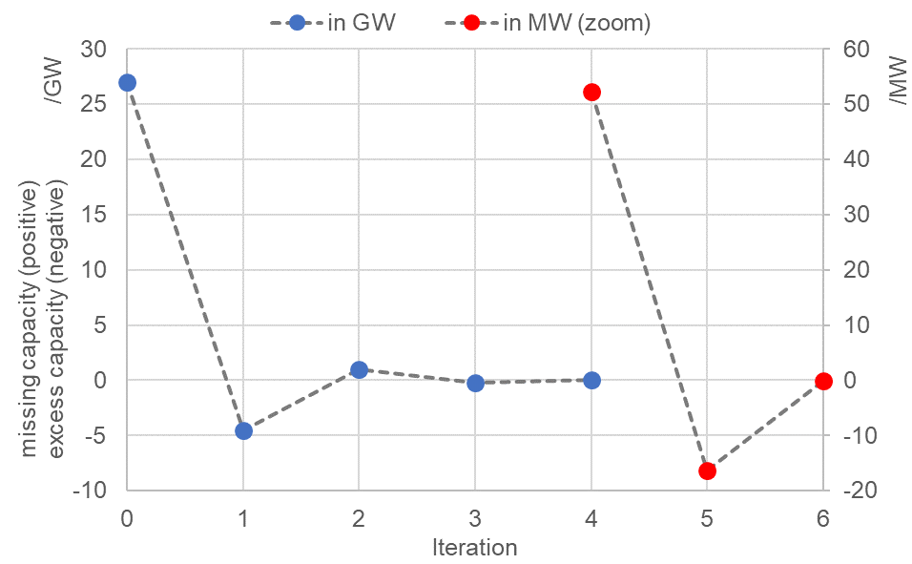
The installed cost-optimal capacities determined by E2M2 do not fully cover the demand in the AMIRIS simulations (see Figure 2). This is mainly caused by a limited foresight in AMIRIS and thus a sub-optimal dispatch of energy storage units. This overly optimistic bias of generation system optimisation models [5] is the first deviance identified by the process. To avoid scarcity and associated harsh market distortions, back-up power plants are installed. Peak usage of those back-up plants in AMIRIS equals the missing capacity and is one coupling parameter returned to E2M2. There, a new constraint is introduced that ensures a minimum capacity factor that is based on the missing (or excess) capacity from the AMIRIS result of the previous iteration. Figure 3 depicts that, after several iterations, E2M2 converges towards an optimal power plant park without missing or excess capacities in AMIRIS: The results are given in GW at first (blue dots) and after some iterations in MW (red dots) due to the progressing convergence.

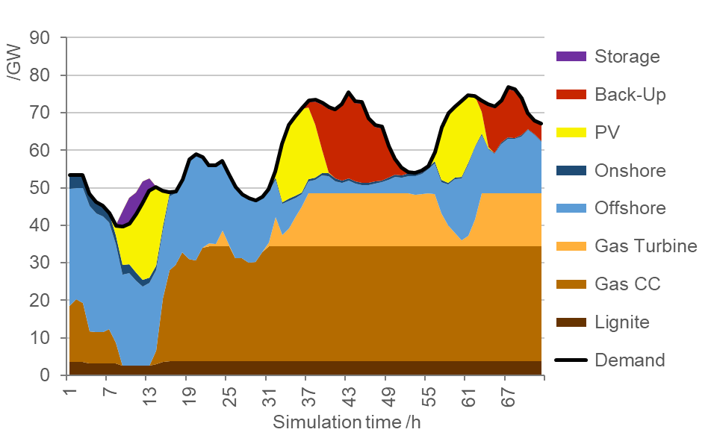
Figure 2: Dispatch in AMIRIS using back-up plants (red)
Figure 3: Missing / excess capacity (positive / negative) in AMIRIS over iterations in GW (blue) and MW (red)

We assess the convergence behaviour of this model coupling approach for different coupling parameters. Furthermore, we compare the original solution to the newly identified realisable optimum and investigate their differences regarding system cost and power plant park composition. In addition, we investigate which support policies cause the least distortion compared to the original optimal system. Furthermore, we discuss possible approaches correcting this bias in generation system optimisation models. These results shall help to further understand the efficiency gap and pave the way towards modelling of more plausible energy systems, and thus, ultimately, better model-based support of policy makers.

Literature

[1] L. Torralba-Díaz et al. „Identification of the Efficiency Gap by Coupling a Fundamental Electricity Market Model and an Agent-Based Simulation Model”, Energies 13(15): 3920, 2020
[2] http://www.strise.de/projekte/projekte4000/
[3] N. Sun, „Modellgestützte Untersuchung des Elektrizitätsmarktes: Kraftwerkseinsatzplanung und -Investitionen”, Universität Stuttgart, 2013
[4] M. Reeg, „AMIRIS – Ein agentenbasiertes Simulationsmodell zur akteursspezifischen Analyse techno-ökonomischer und soziotechnischer Effekte bei der Strommarktintegration und Refinanzierung erneuerbarer Energien“, Universität Dresden, 2019
[5] H. Scheben, N. Klempp, K. Hufendiek: Impact of Long-Term Water Inflow Uncertainty on Wholesale Electricity Prices in Markets with High Shares of Renewable Energies and Storages, Energies, Vol 13(9), 2020, pp. 2347

