Environomic optimisation of local energy concepts for utility companies under the influence of increased energy prices
Energiesystem- und Klimamodellierung
Jana SCHNEELOCH⁽¹⁾, Lena ROSIN⁽¹⁾
⁽¹⁾ Fraunhofer UMSICHT

Motivation and research question
The current gas crisis has intensified the pressure on utility companies to enforce the decentralisation and decarbonisation of the energy system [1]. They are facing high energy prices while the focus is on the security of supply, especially for residential buildings. Moreover, environmental criteria have become an important metric adjacent to the economic parameters.

Therefore, we optimise the design and operation of different heating systems. Furthermore, we analyse the effect of limited direct emissions on the total costs and assess these systems under environomic criteria. We perform these investigations under the effect of increasing energy prices.

Method
We analyse four different energy systems for the space heating and hot water supply of a typical multi-family house in Düsseldorf, Germany. The technology composition is fixed in each system:
- S1: Heat pump + gas boiler (existing) + thermal storage
- S2: Heat pump + solar thermal collector + thermal storage
- S3: Gas boiler (existing) + solar thermal collector + thermal storage
- S4: Pellet boiler + solar thermal collector + thermal storage

The concepts are modelled as MILP optimisation problems with ESyOpT® which is based on oemof [2]. The objective is to minimize the total costs. In addition, the epsilon-constraint method is used to limit the system’s CO₂-emissions to 90 % of the cost-optimal solution. To investigate the effect of increasing energy prices, the concepts are calculated for average data of the year 2021 and November 2022.

The resulting concepts are assessed and ranked under the metrics of the total annual costs and the total direct annual CO₂-emissions. For this, three methods, TOPSIS [3], EDAS [3] and AHP [4] are used. The two criteria weights have been determined from a survey in which employees of a local utility company participated. The methodology is summed up in Figure 1.

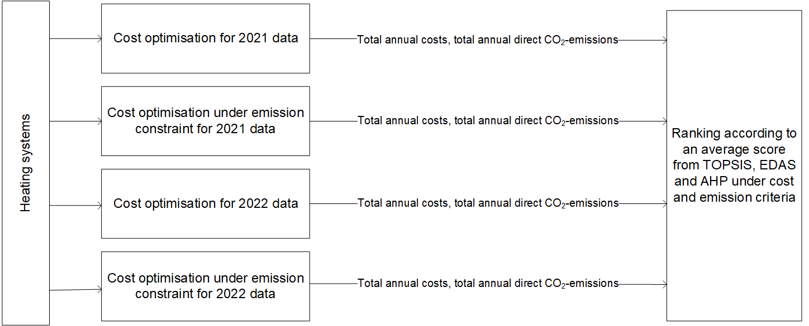
Figure 1: process steps of the method

Results and Conclusions
A reduction of CO₂-emissions by 10 % leads to a cost increase of 10-40 % in 2021. For 2022, the cost increase is only 7-16 %. However due to the increasing energy prices, the systems’ total annual costs without emission constraint have already increased by 69% within one year.

The most significant difference between the optimisation methods can be seen in the built size of the solar thermal collector. Under the CO₂-constraint, the collector area is more than 790 % bigger in each of the regarded systems that include a solar thermal collector. This effect even intensifies in 2022 when the collector area is more than 840 % bigger.

The ranking results (Figure 2) are aggregated from the three different methods. All systems including the scenario variants are ranked among each other. Evidently, the best rated system in both prices scenarios and optimisation objectives is the system with the pellet boiler (S4).

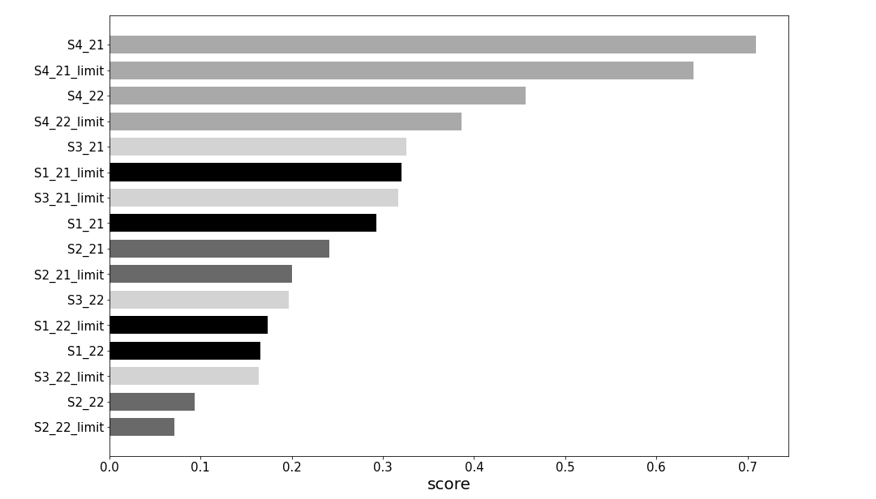Figure 2: Results of the aggregated ranking for all calculated heating systems in all scenarios. The score can lie between 0 and 1. The bars are named after the heating system and the scenario year, and it is indicated if the CO₂-emissions were limited. The colour scheme is geared to the heating system.

The results show that even under increased energy prices, S4 has a higher score than the other systems at lower energy prices. In fact, S4 is the most robust to the price increase under cost and emission criteria. Based on these results, utilities can adapt their product strategies.

Literature

[1] Deutscher Bundestag, Textarchiv, Sachverständige: Wir müssen um jedes Zehntelgrad weniger Erderwärmung kämpfen, 12.10.22
[2] oemof-developer-group, 2021, https://oemof-solph.readthedocs.io/en/latest/
[3] Zhang et al., 2019, Probabilistic multicriteria assessment of renewable micro-generation technologies in households, In: Journal of Cleaner Production, Volume 212, p. 582
[4] Lazaroiu and Ciupageanu, 2019, Multi-criteria decision making in sustainable renewable energy systems. In: 19th International Multidisciplinary Scientific GeoConference Proceedings, Volume 19, Issue4.1, Part A, doi: 10.5593/sgem2019/4.1/S17.042

Jungautorin: Osterfelder Str. 3 46047 Oberhausen Germany, +49-208-8598-1631, jana.schneeloch@umsicht.fraunhofer.de
Jungautorin: Osterfelder Str. 3 46047 Oberhausen Germany, +49-208-8598-0, lena.rosin@umsicht.fraunhofer.de

