Business Models for Energy Communities
Aktive Endkunden-/Prosumerpartizipation & Gebäudesektor
Tobias HOFER⁽¹⁾, Anja GREBE⁽¹⁾, Josef BAUCHINGER⁽¹⁾, Marcellus LOUROZA⁽¹⁾ Thomas NACHT(²⁾ Matthew CLARKE⁽³⁾
⁽¹⁾Fronius International GmbH, ⁽²⁾4ward Energy Research GmbH, ⁽³⁾University of Applied Sciences Technikum Wien

Motivation and central research question
The project UCERS aims to deepen the understanding of the social context in which energy communities (EC) form and operate. The project foresees a continuous stakeholder involvement and an integrated approach to evaluating energy communities that involves considering factors beyond the economic conditions such as environmental and societal factors. The central research question of this paper is what are the key factors and input parameters for business models when it comes to founding and operating an energy community? This project is supported with the funds from the Climate and Energy Fund and implemented in the framework of the RTI-initiative ‘Flagship region Energy’.

Methodical approach
Goal of this paper is the evaluation of the EC-environment including an analysis from a technical point of view, including motivation of founders and potential members, ownership and operation of the EC and specification of real-world business models. The approaches defined in this paper are based on the Austrian national law, in this case the Austrian Energy Expansion Act (‘Erneuerbaren Ausbau Gesetz’) as well as the Electricity Industry and Organisation Act (‘Elektrizitätswirtschafs- und Organisationsgesetz’) (e.g. concerning participants, corporate form and aims of the EC) [1] [2].
For that purpose a definition of the use case is made and the main input parameters describing an use case are defined. Building on the use cases the construct of a business model is defined.

Results and conclusions
The use case describes the general direction and set-up of the EC. The main input factors that were identified include: the combination of participants, their corresponding motivations and local conditions given at the location of a potential EC. These input factors strongly depend on one another and all of them define the use case (see Figure 1). They serve as basic conditions for deciding to form or join an EC.
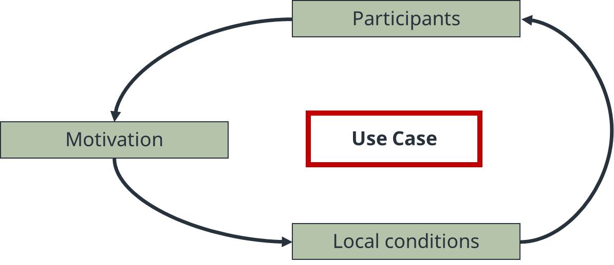

Figure 1: A use case is dependent on the input variables motivation, participants and local conditions

A business model describes how an organization creates, delivers and captures value in economic, social, environmental or further context. The research concluded that the business model of an EC is best described by the combination of use case, ownership, operation and billing model (see Figure 2). This also provides an indication on where the members can influence an EC. Given the situation, that the use case is predefined, the participants in the EC can influence the billing model, ownership and mode of operation.
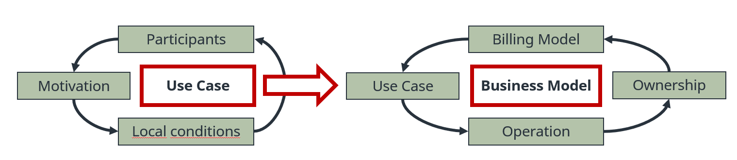
Figure 2: A business model is dependent on different input variables such as use cases, billing models, ownership and operations

An example of an EC in a rural area is described below, using the above mentioned methodology:
The use case has the following input variables. The participants are all neighbours who are either prosumers or consumers. ‘Environmental benefits’, ‘financial benefits’ (use and share locally produced energy to save money) and ‘independence’ are their main motivation for founding the EC. The local condition can be described as neighbouring, detached houses in a rural area with a manageable number of participants. Based on this use case, the business model can be described as follows. Regarding the ownership, the property is owned by each participant. Therefore, they have their own PV, storage, controllable loads and non-controllable loads. The EC will be an association, as it is easy and cost-effective to found, decisions are made directly, participants should be able to join the EC easily and no big investments are planned. An external platform will be used for billing, relying on a billing model that is based on a fixed tariff for shared energy and a fixed fee per month to pay the expenses for the external operation platform.

Other business models can be possible for the above-mentioned use case. E.g. the operation could be done internally and the billing model could be based on payments in goods (car-sharing). The generations units could also be owned by one participant or by all. As described, a lot of different business cases are possible for one use case. Therefore, the paper evaluates the EC-environment and the possible business models for ECs

Literature
[1] Republic of Austria. Renewable Expansion Act. Austrian Federal Law BGBl. I Nr. 150/2021. July 27, 2021. [Online]. Available: https://www.ris.bka.gv.at/Dokumente/BgblAuth/BGBLA_2021_I_150/BGBLA_2021_I_150.html
[2] Republic of Austria. Electricity Industry and Organisation Act 2010t. Austrian Federal Law BGBl. I Nr. 7/2022. 14. February 2022. [Online]. Available: https://www.ris.bka.gv.at/GeltendeFassung.wxe?Abfrage=Bundesnormen&Gesetzesnummer=20007045

Froniusplatz 1, A-4600 Wels, +43 664 888 25 915, Hofer.Tobias@fronius.com, www.fronius.com
Reininghausstraße 13a, A-8020 Graz, +43 664 88 500 336, thomas.nacht@4wardenergy.at, www.4wardenergy.at
Giefinggasse 6, A-1210 Wien, matthew.clarke@technikum-wien.at, https://www.technikum-wien.at

